Christopher Mallon

Town of carver, Massachusetts

A Grant Proposal Requesting Funds from the Parkland Acquisitions and Renovations for Communities (PARC) Program

Carver Shurtleff Park Committee

108 Main St

Carver, MA 02330

(508) 866-3400

December 12, 2019

Executive Office of Energy and Environmental Affairs

Parkland Acquisitions and Renovations for Communities (PARC) Grant Program

Matthew A. Beaton

Saltonstall Bldg, 100 Cambridge St #900

Boston, MA 02114

Dear Mr. Beaton,

My name is Christopher Mallon, and I am writing on behalf of the Carver Massachusetts Recreation Committee. I am writing to request a grant to the amount of $100,000 to renovate Shurtleff Park, in order to give the growing population of Carver a safe, local place to play and enjoy the outdoors.

Carver, Massachusetts is a small town, but one with a big heart. Carver has a tight-knit local community as well as a long, humble history which its residents are intensely proud of. The central location which best captures both of these qualities can be found in the town’s only municipal park, Shurtleff Park. This park functions as a focal point around which the community of Carver congregates; farmers markets, 4th of July celebrations, and of course celebrations of the town’s founding turn Shurtleff park into a hub of local commerce and recreation. On these particular days the park is serviceable enough in its current state, but the use of the park is severely limited at all other times. With the PARC grant, the funds will be put towards expanding the usable space of the park, renovating the existing utilities present within it as well as giving it uses outside of simply being the most convenient public space for certain events.

More than ever the town of Carver is in dire need of new public space; recently, the only public playground in town was torn down to make space for a new police station. With the loss of this core space for the residents of Carver to play and exercise, particularly children and young families, the town has lost a major location for its residents to socialize and truly live together as a community.

I appreciate your time and consideration. Please contact myself or Clark Griffith, head member of the town Shurtleff Park Committee, if you have any questions.

Sincerely,

Christopher Mallon

**Table of Contents**

* STATEMENT OF THE PROBLEM - 1
  + Exercise, the Environment, and Social Capital - 1
  + Loss of Town Playground - 2
* STATEMENT OF REQUEST - 4
* DESCRIPTION OF PROPOSED WORK - 5
  + Objectives and Goals - 5
  + Methods and Practices - 5
  + Schedule Outline - 6
  + Potential Alterations - 7
* DESCRIPTION OF AVAILABLE FACILITIES - 8
  + Shurtleff Park, Carver MA - 8
* PERSONNEL - 10
  + Board of Selectmen - 10
  + Planning Board - 10
  + Conservation Committee - 10
  + Historic District Commission - 11
  + Recreation Committee – 11
  + Christopher Mallon, Principal Investigator - 11
* BUDGET - 12
* SUMMARY AND CONCLUSION - 13
  + Benefits to the Community - 13
* APPENDIX – 14

**STATEMENT OF THE PROBLEM**

**Exercise, the Environment, and Social Capital**

The US is a fractured society. Besides blatant examples of widespread distrust among US citizens such as in news or politics, within our own local communities’ interpersonal connection is scant. The measurement of the strength and productivity of interpersonal bonds within a community is known as “Social Capital.” This encompasses platonic relationships, romantic relationships, familial bonds, civic trust, and so on. In a study of almost every county in the country conducted by Congress’ Joint Economic Committee, it was found that the top fifth of states, in terms of social capital scores, are home to just nine percent of Americans, while 29 percent live in bottom-fifth states. This means that almost a third of US citizens are living in fractured, isolated relationships without the strong bonds necessary for a community to thrive.

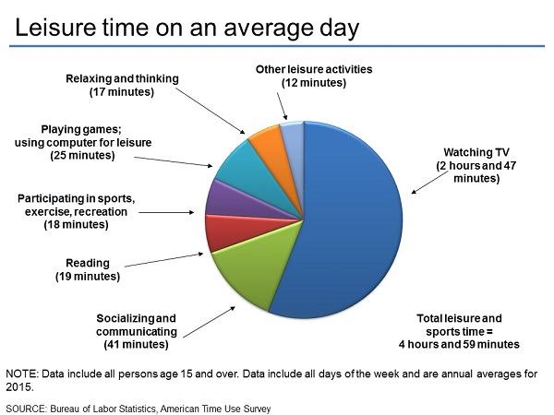

*Figure 1*

In addition to our strained social fabrics, US citizens are also overwhelmingly inactive. In 2018, a National Health Statistics Report found that barely 23% of adult US citizens were reaching the recommended amount of physical exercise for both cardiovascular and muscular health. Besides lack of time or ability, a key component to the US’ exercise deficit is the simple fact that many people don’t have access to the space or equipment necessary for consistent exercise.

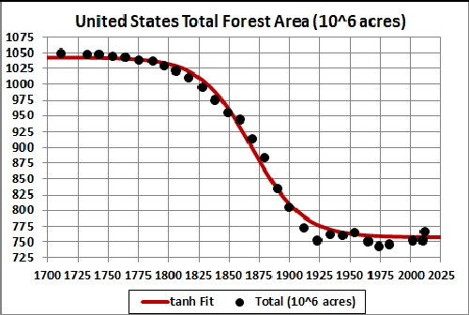

*Figure 2*

Aside from the social ills of the US, the looming threat of climate change becomes more pressing each year. According to the US Forest Service, about 6,000 acres of undeveloped land is lost to development each day, with an estimated change in urban land from 39 million to 69 million acres by 2060.

All of these concerning facts taken together, it is inarguable that now more than ever communities across the country are in need of green, healthy places to exercise and bond.

**Loss of Town Playground**

In January of this year, a proposal was put before the town of Carver to begin the construction of a new police station. Coming off of a prior year marked with the construction of a brand-new elementary school and fire station, the townspeople were happy to continue the process of bringing the town’s public works into the 21st century. Unfortunately, controversy gripped the town once it was learned that the new station was slated to be placed directly on the plot which was then occupied by the town’s only public playground. Outrage erupted, and accusations of foul play on the part of the plan’s architects began to fly.

In one passionate letter sent to the local news center Wicked Local, a writer who only identified themselves as “A Carver Resident” laid these feelings bare. The writer highlights the apparent disregard the plan’s creators had for outside input, especially from the only female board member who did not immediately jump onto the plan, Sarah Hewins:

“It was disheartening to bear witness to the disrespect given to Carver’s citizens during the two-day public forum…Sarah was interrupted, and her comments waylaid until the very end of the whole presentation. When she was allowed to speak and attempted to distribute alternative police building proposal, she was rushed and asked if she was done in a condescending tone, urging her to finish up, so the vote could be taken.”

Despite the backlash, the vote went through, and the playground was subsequently torn down by midyear.

Today, there are mixed feelings about how to recoup the loss of the town playground. The only certain thing is that the town of Carver cares deeply about having an outdoor community space, and is in need one now more than ever.

**STATEMENT OF REQUEST**

The Parkland Acquisitions and Renovations for Communities (PARC) Grant Program seeks to provide the funds necessary to acquire, construct, and/or renovate preexisting parks and public greenspaces in municipalities across Massachusetts. It is a grant offered by the State of Massachusetts to traditionally underserved communities across the state, from poverty stricken urban neighborhoods to small, economically limited rural towns. Fundamentally, the PARC Program bolsters the creation of places which foster healthy, active, interconnected communities where there otherwise would not be.

The PARC Grant is one of the most sought after grants every year, since its generous sums and open accessibility make it invaluable to countless communities in the state. Over the decades, countless municipal parks, playgrounds, hiking trails, and local forests have been constructed, renovated, and conserved across the state thanks to the PARC Program.

Therefore, the town of Carver is seeking funds from the Massachusetts State PARC Grant Program in order to finance the renovation of the town’s only accessible greenspace, Shurtleff Park. With this grant, the residents of Carver will be given access to a public utility which is indispensable for any growing community; a clean, open, up-to-date space to exercise, socialize, and host the many events and celebrations which give the town its unique, local culture.

**DESCRIPTION OF PROPOSED WORK**

**Objectives and Goals**

The aim of the renovation of Shurtleff Park is to:

* Provide the residents of Carver with a new outdoor public place that can be as cherished and valued as the late playground
* Promote exercise, healthy living, and outdoor activity
* Encourage the development of civic pride and participation in public life by the townspeople
* Increase the practical as well as aesthetic value of the park to the town as a whole
* Develop strong community bonds and interpersonal connections between the residents of Carver
* Preserve the long history and unique culture which surrounds the park presently, but with the addition of facilities fit for a dynamic, 21st century park.

**Methods and Practices**

The PARC Program is very open-ended in regards to what kinds of projects it is willing to help fund. Aside from obvious requirements such as the project at hand being a park or outdoor space of some sort, or there being an actual desire for the project in the first place, there are few limits. The only caveat to the PARC Grant fact that the lion’s share of the grant is reserved for communities of 35,000+ residents. Luckily, part of the grant is apportioned to less populated communities thanks to the “Small town” or “Regional” provisions. This simply means that projects applying for the PARC Grant in communities under 35,000 residents will only have access to $100,000 of potential funding, rather than the full $400,000.

To get the process of renovation underway, the town must first hire the service of a certified inspector or land development agency to inspect the land of the park itself. This is to find out what the current state of the land is, what kinds of changes or developments are required by law as well as practical necessity, and any potential constraints the nature of the land will place on the project. For example, construction of wide swathes of land covered by stone, concrete, gravel, etc. decreases the amount of open earth on the property. If the soil of the park has low water retention, a complementary drainage system must be constructed along with the facilities to compensate for the now-increased amount of groundwater collected within the ground of the park. Along with this, all necessary environmental studies, land surveys, and zoning changes must be made.

The investigations of the inspector(s) will be undertaken hand-in-hand with designs put forth by a dedicated land developer. This individual or company will oversee the design, development, and construction of any and all new facilities or utilities. This “brainstorming” stage of the project will see the creation of a rough outline for the project’s development, as well as a unified “vision” of the finished park which will be adhered to by the many operators within the project.

Once the inspections have been complete and the project leaders have been given all necessary information, a complete roadmap of the project will be completed. The roadmap for any given project is always unique, but generally projects such as this one follows these general steps:

Land Packaging Stage: As already discussed, this stage consists of all of the preparatory work necessary before the project can be made underway. All licensing, permits, land planning, and other “paper enhancements” are made during this stage. Likewise, all on-site prep work such as land surveys, environmental studies, and zoning changes are completed during this stage.

Land Development Stage: This is the beginning stage of the project proper, but still before the installation or renovation of any buildings or facilities on the property. This stage sees the development of “Horizontal” infrastructure, such as the apportioning of new land plots, tearing up old soil, grass, trees, etc. Likewise, all old structures and defunct facilities will be cleared, and paths, fences, gas/water utilities, and the foundations of any new buildings will be laid out during this stage. Due to the nature of this project, the majority of the renovations necessary will most likely occur within this stage.

Building Development Stage: This stage builds off of the developments of the previous stage, leading to the development of the project’s “Vertical” infrastructure; all new structures, above-ground utilities, renovations of existing structures, etc. will be installed during this stage.

Operating Stage: This stage closes out the bulk of the project’s construction. All last-minute fixtures, installations, aesthetic landscaping, and other “finishing touches” will be completed in this stage. Usually this is the stage in which the land developer would lease the property to any potential buyers, but in this case the town will retain ownership of the property. From here on the park should be near complete if not entirely complete, and thus the park should be set for public use, i.e. operation.

**Schedule Outline**

A definitive schedule for projects such as this can be quite variable, as developments during the construction process itself may help or hinder the project as a whole. On average, projects of this kind can take anywhere around 36 months to complete. Luckily for this project however, the park itself is significantly smaller than other projects of its kind, and will not involve major facilities such as baseball fields or entire recreation centers. With all of this in mind, and assuming that the whole process is begun at the beginning of next year, a good outline of the project’s schedule may look like this:

Land Packaging Stage: 4-6 months

Land Development Stage: 8-10 months

Building development Stage: 6-8 months

Operating Stage: 1-2 months

Total Timescale: 2 - 2½ years

**Potential Alterations**

The length of the project allows for consistent input on the part of the designers, as well as the townspeople themselves. After a year, or at about the midpoint of the project, a hearing can be called to reflect on the progress of the project, as well as deliberate on any developments in the designs or changes of opinion on the part of the town’s residents. If circumstances surrounding the project change from when the Land Packaging Stage began – costs are higher or lower than expected, progress is faster or slower than planned for, etc. – then at this point adjustments can be made.

For example, if it turns out that the land of the park is unsuitable for the creation of a new picnic area, plans for one can be cut before the plot for one is laid down. Likewise, if it turns out that a picnic area can in fact be included and there is great support for it among the townspeople, an expanded one can be added to the initial plan. Changes such as this should be kept within reason, since the budget and timescale must always be kept in mind, but the potential for alteration allows for the crafting of a park that truly fits the local mould of Carver.

**DESCRIPTION OF AVAILABLE FACILITIES**

**Shurtleff Park, Carver MA**

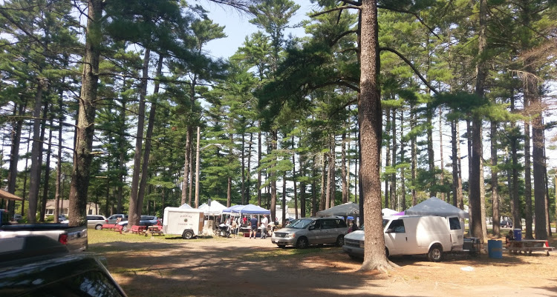

*Figure 3*

Shurtleff Park is an approximately 5-acre piece of land owned and maintained by the town of Carver, Massachusetts, located across from the town center at 108 Main St. The land was given to the town in 1908 by Carleton Shurtleff Francis, a descendant of Carver native Benjamin Shurtleff.

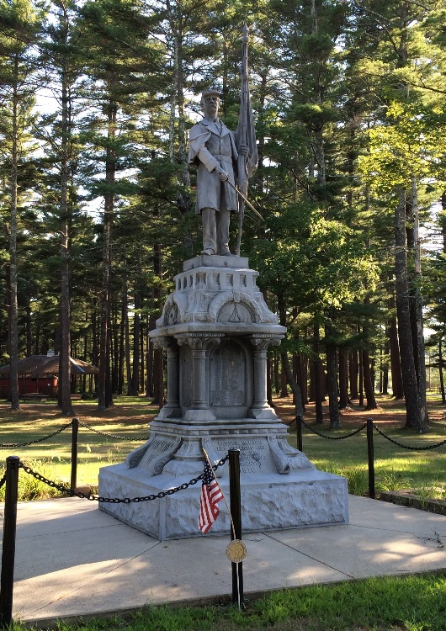

*Figure 4*

On the corner of Main and West Streets, a memorial statue was erected in 1910 to honor Carver veterans of all wars up to and including the Civil War and the Spanish American War. To the left of this sits a memorial stone dedicated in 1948 to the memory of veterans who served in World War I and World War II.

As one can see, Shurtleff park has a long and well-loved history. It is home to a weekly farmers market, and is the beating heart of Carver’s celebration of the town’s heritage, Old Home Day.

Despite this, the park is very limited in scope and use in its current state; it is unused save for once a week, and only for a handful of celebrations a year. And this is of course not to mention the few outdated fixtures of the park; for example, one of the few structures within the park is a bandstand built by the civic group, Carver Active People, in 1988. Aside from a few tables installed at about the same time, the park has not received any update to its features in over thirty years. Since 1980, the town of carver has increased in size approximately 1.5x, from ~7,000 residents to ~11,500 and counting. Combined with the loss of the town’s only public playground, Shurtleff Park is ripe for redevelopment into a new, active greenspace right in the center of town.

**PERSONNEL**

**Carver Board of Selectmen**

The Board of Selectmen is the central political organ within the town. Each board member has been elected by the town of Carver to represent their general interests, and as such they play a part in nearly every public development within the town.

* Ronald E. Clarke - Chairman
* Mark Townsend - Vice Chairman
* Sarah G. Hewins - Member
* Robert Belbin - Member
* Alan Dunham - Member

**Planning Board**

The Planning Board’s primary function is to administer the town’s zoning and subdivision laws, as dictated by local as well as state law. Each member is elected by the residents of Carver, and help ensure all zoning and land development projects within the town are legal and up to code.

* Bruce Maki - Member
* Kevin Robinson - Member
* William Sinclair - Member
* Jennifer Bogart - Member
* James Hoffman - Member

**Conservation Commission**

The Town Conservation Commission is tasked with ensuring the environmental health of the town. This volunteer board enforces Massachusetts’ Wetland Conservation Act, designed to protect the sensitive ecosystem of the state. Nearly 50% of the Carver’s area is considered wetland, with the remaining upland playing a key role in maintaining the health and stability of Carver’s earth.

* James Nauen - Chairman
* Alan Germain - Member
* Savery Moore - Member
* Tim Dempsey - Member
* Dan Badger - Member

**Historic District Commission**

The Historic District Commission is a volunteer committee within the town government, dealing with protecting and preserving Carver’s historic locales and artifacts. Since Shurtleff Park contains several historic monuments, as well as being a historic district itself, the committee will work with the town to ensure the history of the park is preserved.

* Margret H. Blackwell - Chairman
* Savery Moore - Alternate
* David W. Wainio - Member
* James Philip - Member

**Recreation Committee**

The Carver Recreation Committee consists of five volunteer members who oversee the recreation of the town, such as local sports teams, ball parks, soccer and football fields, and so on. Once the renovation is underway, this committee will work to furnish it with the equipment necessary to make it a welcoming and useful space for the town’s residents.

* Mary E. Ross
* Ellen Sordillo
* Karl Miller
* James Hoffman
* Nicole Tully

**Christopher Mallon, Principal Investigator**

I am specialized in technical writing and communication after four years of study at the University of Massachusetts Amherst, and I possess over five years of hands on experience in the field of land survey and land development. In addition to this, I am a lifelong Carver resident and passionate advocate for the growth and development of my community. Beyond this proposal, I am ready and able to assist in all further investigations and analysis necessary to ensure the speedy and efficient completion of this project.

**BUDGET**

Normally a project such as this would fall far beyond the funds available in the PARC Grant’s small-town procurement, at about $200,000 - $400,000. But due to the small size and limited addition of new park features, the cost of renovation can safely fall within the $100,000 ballpark.

**Landscaping & Scenery**

General Landscaping (grass/soil removal or installation, tree trimming, etc.) - $10,000

Park Amenities (trash cans, water fountains, benches, etc.) - $7,500

Picnic Area Installation - $10,000

Stonework (walkways, sidewalk re-pavement, monument renovation, etc.) - $15,000

**Facility Installation and Renovation**

New Bandstand - $15,000

Public Bathroom Renovation - $5,000

Signage - $5,000

New Playground Surfacing & Equipment - $25,000

**Estimated Total Cost:** $92,500

**SUMMARY AND CONCLUSION**

**Benefits to the Community**

Parks and recreational facilities are integral to the health of any community’s residents, as well as the environment as a whole. Across the country, preventable health issues, the decay of community bonds, wasteful environmental destruction are wreaking havoc. And it is in rural, lower-income areas that the effects of these trends hit the hardest. Now more than ever government funds should be put forward towards combating these evils and reestablishing the health and wellbeing of local communities countrywide.

Carver is not a particularly large or wealthy town, but its residents care about their home, and wish to see their community grow and thrive as much as any other. Not only that, but they take great pride in the long history and unique local culture of Carver, so much so that hundreds of former residents make a pilgrimage back to their old home to celebrate with current residents on Old Home Day.

By renovating Shurtleff Park, the residents of Carver will be given exactly what they cry out for; a clean, green, accessible place where residents are able to exercise, play, and celebrate the unique beauty and culture of their beloved town.

In sum, the Town of Carver, Massachusetts urges the Executive Office of Energy and Environmental Affairs to help its residents take action to preserve and improve the health and wellbeing of their town and community as soon as possible.

**APPENDIX**

**Figures and Illustrations**

**Figure 1:** Leisure time for persons age 15 and over on an average day, Bureau of Labor Statistics

**Figure 2:** Graph of total US forest area, US Forest Service

**Figure 3:** Weekly farmers market in Shurtleff Park, Carver MA

**Figure 4:** Carver Veterans Memorial Statue, 1910

**Bibliography**

Blackwell, Deborah L., and Taniya C Clarke. Center for Disease Control and Prevention, 2108, *State Variation in Meeting the 2008 Federal Guidelines for Both Aerobic and Muscle-Strengthening Activities Through Leisure-Time Physical Activity Among Adults Aged 18–64: United States, 2010–2015*.

“Carver, Massachusetts.” *Wikipedia*, Wikimedia Foundation, 15 Sept. 2019, en.wikipedia.org/wiki/Carver,_Massachusetts#Demographics.

Kohlhepp, Daniel B. *The Real Estate Development Matrix*. www.ccimef.org/pdf/2012-299.The-Real-Estate-Development-Matrix.4-21-12.pdf.

“Lack of Physical Activity.” *Centers for Disease Control and Prevention*, Centers for Disease Control and Prevention, 25 Sept. 2019, www.cdc.gov/chronicdisease/resources/publications/factsheets/physical-activity.htm.

“LETTER: Concerned about Playground Process.” *Wicked Local*, 10 Jan. 2019, carver.wickedlocal.com/news/20190110/letter-concerned-about-playground-process.

“Loss of Open Space.” *Loss of Open Space | US Forest Service*, www.fs.fed.us/science-technology/loss-of-open-space.

“Parkland Acquisitions and Renovations for Communities (PARC) Grant Program.” *Mass.gov*, www.mass.gov/service-details/parkland-acquisitions-and-renovations-for-communities-parc-grant-program.

“Project Timeline: MNCPPC, MD.” *Project Timeline | MNCPPC, MD*, www.pgparks.com/513/Project-Timeline.

United States Joint Economic Committee. “The Geography of Social Capital in America.” *The Geography of Social Capital in America - The Geography of Social Capital in America - United States Joint Economic Committee*, 11 Apr. 2018, [www.jec.senate.gov/public/index.cfm/republicans/2018/4/the-geography-of-social-capital-in-america#toc-007-backlink](http://www.jec.senate.gov/public/index.cfm/republicans/2018/4/the-geography-of-social-capital-in-america#toc-007-backlink).